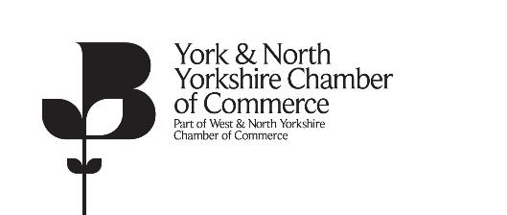

Nomination Form for the York & North Yorkshire Leadership Group 2021

PART ONE – for the candidate to complete (after reading the nominations guide)

Candidate’s name:

Company name:

Membership No. Membership Fees up to date?
Yes (please tick to confirm)
Position in Company:

Company address:

Postcode: (please attach a company letterhead to this form)
Office telephone no. Mobile no.

e-mail address:

Home address:

Postcode:

For completion by the candidate

Why are you seeking election to the York & North Yorkshire Leadership Group?

What would you bring to the group?

Would you be willing to act as an ambassador of the Chamber e.g. attending and taking a role at
events and meetings?

Candidate’s signature Date

Proposer’s section overleaf……

PART TWO – for completion by the person proposing the candidate (must hold a senior role in another company in membership of the Chamber)

I wish to propose the following person for election as a member of the York & North Yorkshire Leadership Group to serve for three years from 6 July 2021 and I confirm that the candidate is not a colleague or employee in my organisation.

Name of Candidate:

Proposer’s name:

Proposer’s company name:

Position in company:

Company Address:

Postcode:
Office telephone no: Mobile no.

e-mail address:

Signature of proposer: Date:

The completed form is to be received by 1pm on 16 June 2021 addressed to Debra Patchett, West & North Yorkshire Chamber, Devere House, Vicar Lane, Bradford, BD1 5AH.
Telephone number 01274 772777 email to debra.patchett@wnychamber.co.uk

